Cairo University Faculty of Computers and Artificial Intelligence



**Software design specification document**

**2022**

**Project Team**

# 

# Class diagram design

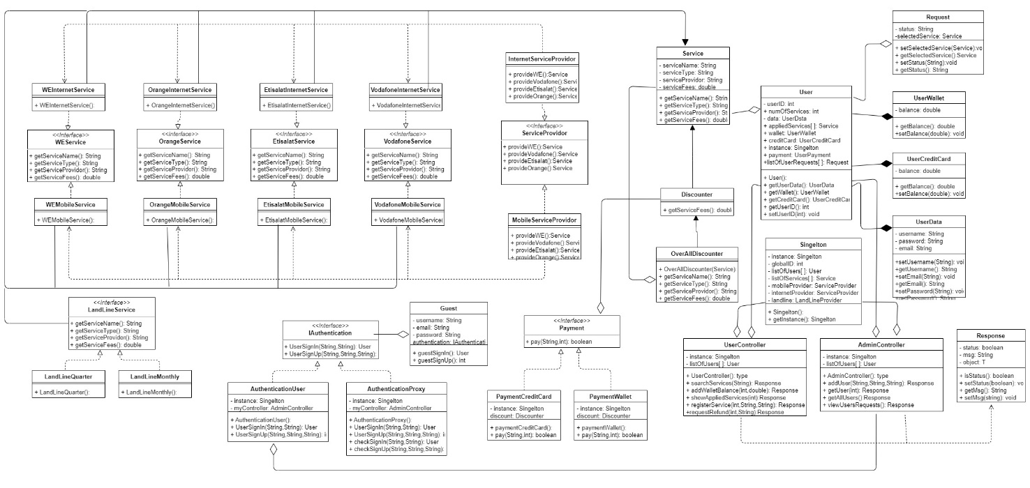

# Class diagram Explanation

* **We used proxy pattern in classes iAuthentication, authenticationUser and authenticationProxy and can be invoked by class guest**
* **We used singleton class pattern to take instance from data and not creating it many times all over the system**
* **We used abstract factory method to deliver services as shown above.**
* **We used strategy pattern to distinguish the behavior when paying with credit card or wallet you can notice it in iPayment, paymentCreditCard and paymentWallet and also in landline services.**
* **We used decorator pattern in class discounter and overall discounter with class service to add discounts to services.**

# Requirements Exposure as Web Service API

**Part 1: Exposed Postman Collection**

**https://speeding-firefly-554014.postman.co/workspace/Team-Workspace~86c191c1-98ad-4eef-83db-9ba1edcd4455/collection/25014860-29cc5b80-27b1-4326-bab7-0474bb31bb9a?action=share&creator=25014860**

**Part 2:**

|  |  |  |
| --- | --- | --- |
| Requirement |  | Exposed API |
| System should check if username and email is registered before |  | /adminController/addUser/{username}/{password}/{email}  A service to check if the user exists before or not and if not existed creates new account with given credentials.  Input: username, password and email. |
| Retrieve all users that have accounts |  | /adminController/getAllUsers  A service to retrieve all users signed up to our system.  No input required. |
| Register in available services |  | /userController/registerService/{userID}/{serviceName}/{paymentType}  A service to make user capable to register in any service available in system and choose payment method before checking having the required balance in his wallet or credit card.  Input: user ID, service name and payment method. |
| Search services in available services in system |  | /userController/searchServices/{searchKey}  A service that searches services with user search key given.  Input: search key. |
| Add funds to wallet |  | /userController/addWalletBalance/{userID}/{balance}  A service to add funds to user wallet from credit card after checking credit card to has required balance to transfer.  Input: user id and amount to transfer. |
| Show registered services |  | /userController/showAppliedServices/{userID}  A service to show applied services by user.  Input: user id. |
| Request transaction refund from system |  | /userController/requestRefund/{userID}/{serviceName}  A service to request transaction refund by a user to system.  Input: user id and service to refund. |

# GitHub repository link

* **https://github.com/muhammed3iid/FawryLikeSystem.git**